# Naive Bayes

**Instructions:**

Please share your answers filled in-line in the word document. Submit code separately wherever applicable.

Please ensure you update all the details:

**Name: _____________ Batch ID:** ___________

**Topic: Naïve Bayes**

**Guidelines:**

**1. An assignment submission is considered complete only when correct and executable code(s) are submitted along with the documentation explaining the method and results. Failing to submit either of those will be considered an invalid submission and will not be considered as correct submission.**

**2. Ensure that you submit your assignments correctly and in full. Resubmission is not allowed.**

**3. Post the submission you can evaluate your work by referring to keys provided. (will be available only post the submission).**

**Hints:**

1. **Business Problem**
   1. **What is the business objective?**
   2. **Are there any constraints?**
2. **Work on each feature of the dataset to create a data dictionary as displayed in the below image:**

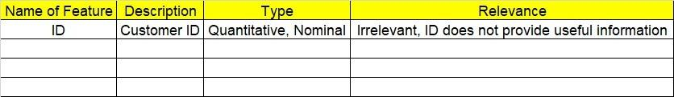

**2.1 Make a table as shown above and provide information about the features such as its data type and its relevance to the model building. And if not relevant, provide reasons and a description of the feature.**

1. **Data Pre-processing**

**3.1 Data Cleaning, Feature Engineering, etc.**

1. **Exploratory Data Analysis (EDA):**
   1. **Summary.**
   2. **Univariate analysis.**
   3. **Bivariate analysis.**
2. **Model Building**
   1. **Build the model on the scaled data (try multiple options).**
   2. **Build a Naïve Bayes model.**

**5.3 Validate the model with test data and obtain a confusion matrix, get precision, recall, and accuracy from it.**

**5.4 Tune the model and improve the accuracy**

**6. Write about the benefits/impact of the solution - in what way does the business (client) benefit from the solution provided?**

**Problem Statement:**

1.) Prepare a classification model using the Naive Bayes algorithm for the salary dataset. Train and test datasets are given separately. Use both for model building. 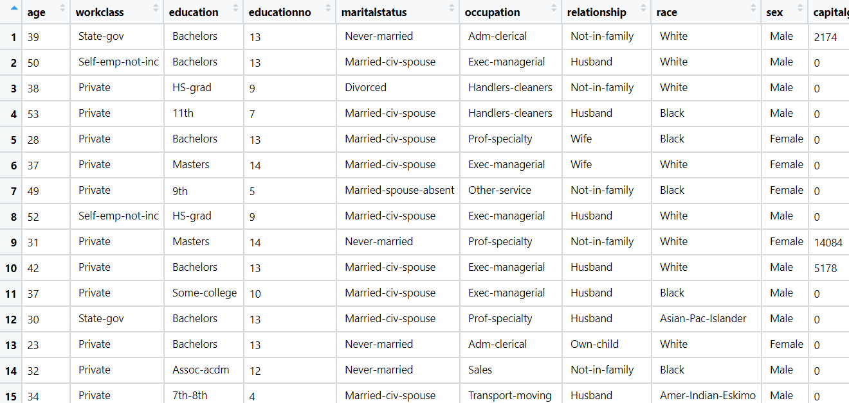

**Problem Statement: -**

This dataset contains information of users in a social network. This social network has several business clients which can post ads on it. One of the clients has a car company which has just launched a luxury SUV for a ridiculous price. Build a Bernoulli Naïve Bayes model using this dataset and classify which of the users of the social network are going to purchase this luxury SUV. 1 implies that there was a purchase and 0 implies there wasn’t a purchase.

**Problem Statement: -**

In this case study, you have been given Twitter data collected from an anonymous twitter handle. With the help of a Naïve Bayes model, predict if a given tweet about a real disaster is real or fake.

1 = real tweet and 0 = fake tweet

